AI-Driven Decision Intelligence for IPL Player Auction Analytics and Team Strategy Optimization

Anurag Kamble1, Shruti Suryawanshi2, Omkumar Sirmalwad3, Saurabh N. Mehta4, Kiran Talele5
Student, Sardar Patel Institute of Technology, Mumbai, India ^{1,2,3} Sardar Patel Technology Business Incubator (SP-TBI), Mumbai, India⁵ VIT Mumbai, Mumbai, India⁴
anurag.kamble25@spit.ac.com¹, shruti.suryawanshi25@spit.ac.com², omkumar.sirmalwad25@spit.ac.com³ saurabh.mehta@email.com⁴, kiran.talele@spit.ac.in⁵

Abstract— Every year, IPL franchises make important player-selection and bidding decisions during a limited auction period. This work presents an AI-driven framework for IPL auction analytics using two complementary studies. Study 1 uses XGBoost regression for auction price prediction under random, time-based, and regularized settings, achieving a test R² of 0.6580 on a random split and 0.5395 on a time-based split. The results also show that temporal evaluation provides a more realistic measure of model performance and highlights the effect of overfitting.
Study 2 develops a quantile-based framework for role-specific ranking and classification of IPL batters and bowlers using performance data. This approach provides a more interpretable evaluation by considering batting and bowling performance separately rather than using a single combined score. Overall, the studies highlight the potential of data-driven player evaluation while showing that auction price prediction remains constrained by factors such as retention history, franchise budgets, recent form, and injury status.
Keywords— IPL auction analytics, XGBoost, auction price prediction, quantile classification, player ranking, sports analytics, decision intelligence, machine learning

- Introduction
The Indian Premier League (IPL) auction concentrates a large number of player-selection decisions into a short pe-riod. Franchises must estimate player value, anticipate future performance, construct a balanced squad, and operate within financial and squad-composition constraints. They must also respond to competing bids during the auction process. Con-ventional measures such as batting average, strike rate, and economy rate provide useful information, but they do not completely represent player consistency, match contribution, role suitability, or squad-level requirements.
The internship focused on the theme “AI-Driven Decision Intelligence for IPL Player Auction Analytics and Team Strat-egy Optimization.” The objective was to investigate the extent to which machine-learning and statistical ranking methods can support data-driven player evaluation while identifying limitations of the available data.
Two practical studies were conducted:
- Study 1 – Auction Price Prediction: An XGBoost regres-sion model was developed to predict auction sale prices. Three experiments were performed to examine the effects of random splitting, time-based evaluation, categorical en-coding, and regularization.
- Study 2 – Player Ranking: A quantile-based classification framework was developed for batting and bowling per-
formance using ball-by-ball delivery data for a longevity-qualified pool of IPL players appearing across every season from 2012 to 2025.
The central methodological principle of this work is that reported model performance is meaningful only when the evaluation protocol is explicitly defined. A single accuracy or R² value without information about data splitting, feature construction, and temporal availability can provide an overly optimistic estimate of real-world performance.
- Related Work
Prior research establishes several of the individual compo-nents used in this study but does not combine them into a trans-parent, cricket-specific auction decision-support framework.
Schelling and Robertson [1] propose a CRISP-DM-based decision-support framework for high-performance sport. Passi and Pandey [2] applied Naive Bayes, Decision Trees, SVM, and Random Forest models to cricket-performance prediction using ESPN Cricinfo data, reporting approximately 90.7% batting and 92.3% bowling accuracy. However, their work did not address auction valuation.
Bunker and Thabtah [3] introduced the SRP-CRISP-DM framework for sports prediction and emphasized appropriate evaluation strategies. Vaswani et al. [4] and Devlin et al. [5] introduced Transformer and BERT architectures, which are

relevant to future sequence-based player-performance mod-elling.
Hyndman and Athanasopoulos [6] describe forecasting methods such as ARIMA and exponential smoothing that can be applied to performance trajectories. He and Garcia
[7] review approaches for imbalanced learning, including resampling and cost-sensitive methods, which are relevant to underrepresented high-value auction players.
Lamas et al. [8] provide an optimization perspective for team selection under budget and squad-composition con-straints. Doshi-Velez and Kim [9] and Mehrabi et al. [10] discuss interpretability and fairness considerations in machine-learning systems. Amershi et al. [11] emphasize the impor-tance of the complete machine-learning engineering lifecycle. Chen and Guestrin [12] introduced XGBoost, the regression algorithm used in Study 1.
- Dataset Description
A. Study 1: IPL Auction Records
Historical IPL auction records containing N = 1,108 rows and 42 raw features covering the period 2008–2017 were used for auction-price prediction.
The dataset contains player statistics and auction-related attributes, including Runs, Matches, Sixes, Fours, Wickets, lagged statistics such as LRuns, LMatches, LSixes, LFours, and LWkts, player Status, Age, Year, and the actual auction sale price.
B. Study 2: Ball-by-Ball Delivery Records
Ball-by-ball delivery records covering the 2012–2025 sea-sons were used to reconstruct player-level performance.
Player appearances were identified using the batter, bowler, and non-striker fields. Players appearing in every season across the 14-season period formed the longevity-qualified pool.
The resulting pool contained 11 qualifying players. Ex-tending the analysis window to 2008 reduced the qualifying population to four players, which was considered too small for meaningful quantile classification. Therefore, 2012–2025 was retained as the primary analysis window.

TABLE I Dataset Summary
or arbitrary fixed thresholds, while evaluation procedures are designed to reduce optimistic estimates of performance.
Figure 1 (Fig. 1) illustrates the Study 2 processing pipeline from the 2012–2025 raw ball-by-ball data through aggregation and quantile-based classification.
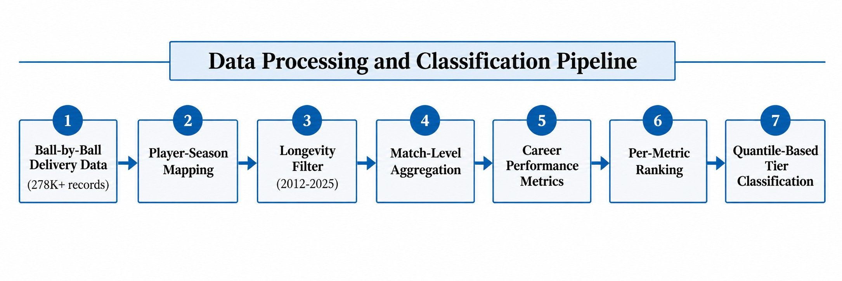

Fig. 1. Study 2 data-processing pipeline: ingestion of the 2012–2025 IPL ball-by-ball dataset, match-level aggregation, and quantile-based player classification.

A. Study 1: XGBoost Auction Price Prediction
- Categorical Encoding: Experiment 1 used LabelEn-coder, assigning each category an integer c ∈ {0, . . . , k − 1}. This representation can introduce an artificial ordering be-tween categories.
Experiments 2 and 3 replaced this representation with one-hot encoding using a ColumnTransformer.
- Feature Engineering: Seven engineered features were
used to represent performance trajectories and career-stage effects: RunGrowth, MatchGrowth, AverageGrowth, StrikeR-ateGrowth, WicketGrowth, EconomyChange, and AgeSquared. The first six compare the current-season statistic with the corresponding previous-season statistic, while AgeSquared captures a nonlinear career-age effect.
For example,
RunGrowth = Runst − Runst−1 , (1)
Runs_{t−1} + ϵ
where ϵ is a small constant used to avoid division by zero. The same formulation is applied to Matches, Average, Strike Rate, and Wickets, while EconomyChange measures the corresponding change in economy rate.
- Model: XGBoost forms an additive ensemble of re-gression trees and minimizes a regularized objective. Tree

complexity and L1/L2 regularization can be controlled to

Attribute Value
Auction records (Study 1) 1,108 rows, 42 features Auction record span 2008–2017
Study 1 encoding (Exp. 1) LabelEncoder
Study 1 encoding (Exp. 2, 3) OneHotEncoder + ColumnTransformer Study 1 engineered features 7 engineered features
Ball-by-ball span (Study 2) 2012–2025
Longevity-qualified players 11
Study 2 minimum sample threshold 15 innings

reduce overfitting [12].
- Evaluation Metrics: The models were evaluated using Mean Absolute Error (MAE), Root Mean Squared Error (RMSE), and the coefficient of determination (R²).
The coefficient of determination, or R², measures the pro-portion of variation in the observed auction prices that is explained by the model relative to a baseline that predicts the mean target value. It is defined as
R = 1 − ∑︁ (y − y¯)2 , (2)

- Methodology
The two studies use independent analytical pipelines but share a common design philosophy. Rate-based and distribution-relative measures are preferred over raw totals
₂ ∑︁i(y_{i} − yˆ_{i})²

i
i
where y_{i} is the observed auction price, yˆ_{i} is the predicted price, and y¯ is the mean observed price. An R² value closer

to 1 indicates that the model explains more of the variation in the target on the evaluated dataset, whereas a value near 0 indicates little improvement over the mean-prediction baseline.
- Composite Z-Score: An earlier iteration used standard-ized z-scores:
x_{i} − µ

R² can also be negative when the model performs worse than
that baseline on unseen data.
z_{i} =
. (7)
σ

In this study, R² is important because it provides a common measure for comparing the explanatory performance of the three auction-price experiments. The random-split test R² of 0.6580 indicates that the model explains approximately 65.8% of the observed variation in the held-out sample under that evaluation protocol, while the time-based test R² of 0.5395 indicates that approximately 53.95% of the variation is explained under the season-aware evaluation. The difference demonstrates why R² should be interpreted together with the data-splitting strategy rather than as a standalone measure of model quality.
For future decision support, R² can be monitored when new seasons or additional contextual variables are introduced. A comparison of out-of-sample R² values can help determine whether a new feature set or modelling approach improves the model’s ability to explain auction-price variation. However, R² does not provide an exact bid recommendation and should be considered together with MAE, RMSE, temporal validation, and the availability of decision-time features.
- Bias-Variance Proxy: The train-test R² gap was used as an empirical diagnostic:
Lower-is-better metrics were sign-inverted before aggrega-tion.
This composite score is retained only as a supplementary analysis because a batting-weighted formulation can disadvan-tage specialist bowlers.
- Quantile-Based Tier Classification: Batters were divided into five tiers using quintiles of batting average, while bowlers were divided into four tiers using quartiles of WPM.
For a distribution X with cumulative distribution function
F , the k-th quantile boundary is
Q = F⁻¹ (︃ k )︃ , k = 1, . . . , q − 1. (8)
q
k
Here, q = 5 for batting quintiles and q = 4 for bowling quartiles.
A minimum sample threshold of 15 innings was applied before ranking.
- Results
- Study 1: Auction Price Prediction

TABLE II

2 2
∆R = R
train
2
test
— R
. (3)
XGBoost Experiment Comparison

A large gap indicates that the model fits the training data substantially better than unseen data.
- Study 2: Quantile-Based Player Ranking
  - Career Feature Aggregation: Delivery-level records were first aggregated to the match level and then summed across the career to avoid double-counting.
Batting average is defined as career runs divided by career dismissals, while strike rate is calculated as runs scored per 100 balls faced.
Average = Career Runs , (4) Career Dismissals
SR = Runs × 100. (5)
Balls Faced
Experiment Train R2 Test R2 MAE RMSE

Exp. 1: Baseline | 0.9888 | 0.6580 | INR 12.77M INR 17.72M
Exp. 2: Time-based | 0.9888 | 0.5395 | INR 14.89M INR 22.36M
Exp. 3: Regularized | 0.7969 | 0.4115 | – –

For bowling,
WPM = Career Wickets . (6) Career Bowling Innings
WPM was used as a workload-normalized measure of wicket production.
  - Independent Per-Metric Ranking: Instead of collapsing all players into one composite score, performance metrics were

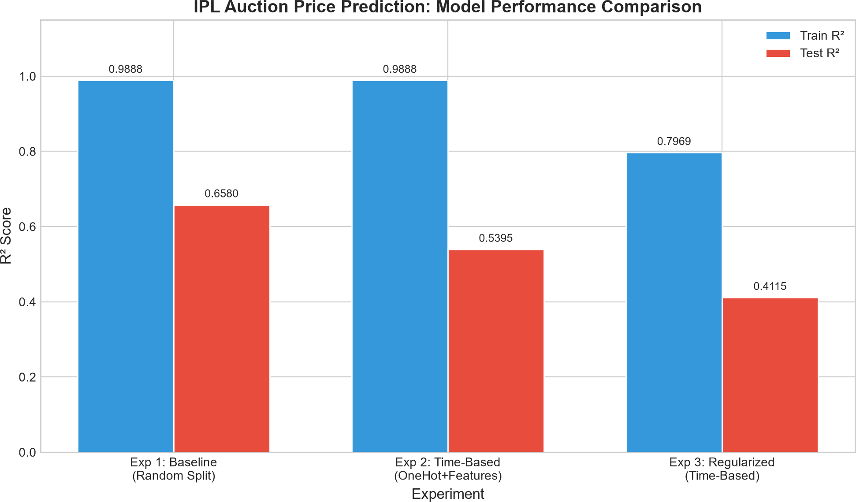
Fig. 2. IPL Auction Price Prediction: Model performance Comparison

- Worked Calculation: Quantifying the Evaluation Differ-ence: The test-set performance difference between Experi-ments 1 and 2 is

considered independently.
Batting metrics included average, strike rate, innings, hun-
2
test
∆R
= 0.6580 − 0.5395 = 0.1185. (9)

dreds, and fifties. Bowling metrics included innings, wickets-per-match, economy rate, and bowling average.
The train R² remains 0.9888 in both experiments, while the time-based evaluation produces a lower test score.

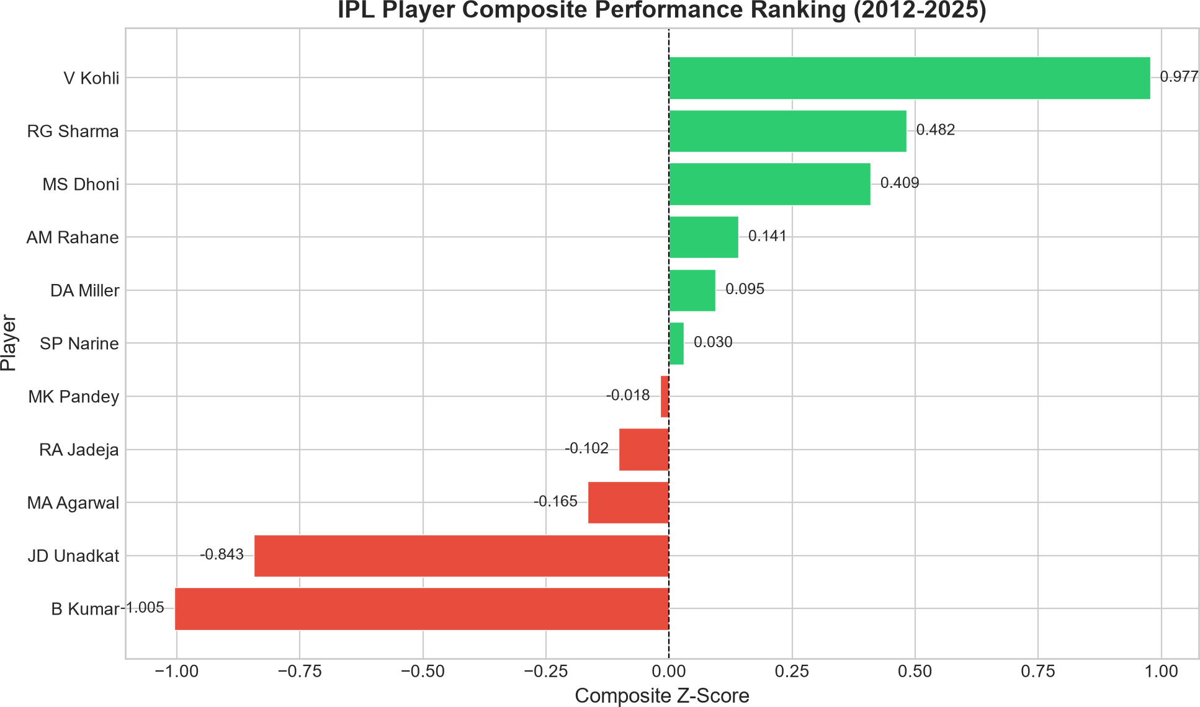
This indicates that the random split provides a more opti-mistic estimate than the season-aware split.
- Worked Calculation: Bias-Variance Tradeoff: For Exper-iment 2,

2
∆R
Exp2
= 0.9888 − 0.5395 = 0.4493. (10)

For Experiment 3,

2
∆R
Exp3
= 0.7969 − 0.4115 = 0.3854. (11)

The reduction in the train-test gap is
0.4493 − 0.3854 = 0.0639. (12)
The relative reduction is approximately
0.0639

Fig. 3. IPL player composite performance ranking for the longevity-qualified population from the 2012–2025 Study 2 dataset.

0.4493
× 100 ≈ 14.2%. (13)
These results demonstrate that career runs, batting average,

However, the test R² also decreases:
0.5395 − 0.4115 = 0.1280. (14)
Thus, the regularized configuration reduces the train-test gap but does not improve the observed test performance on this dataset.
- Feature Importance and Leakage: The top predictive features included Status, LMatches, LRuns, LSixes, LWkts, LFours, Runs, Matches, Age, and Year, with Status ranked first. Removing Status reduced model performance, indicating that the feature contains statistical signal. However, predictive
signal does not establish causal validity.
A feature should only be considered appropriate for auction prediction if its value is available before the bidding decision. The exact relationship between Status and auction outcomes cannot be fully resolved from the available dataset and there-fore represents a limitation.
B. Study 2: Player Ranking and Classification
- Composite Z-Score Ranking: The supplementary batting-weighted composite ranking produced a score of 0.977 for V. Kohli, followed by R. G. Sharma with 0.482 and
M. S. Dhoni with 0.409.
B. Kumar and J. D. Unadkat received negative composite scores. These values illustrate the limitation of applying a batting-weighted composite to players with different primary roles.
- Batting Comparison: Career runs are led by V. Kohli with 8,628, followed by R. G. Sharma with 6,973 and M. S. Dhoni with 5,391.
When batting average is considered, V. Kohli records 39.56, followed by M. S. Dhoni with 38.30.
D. A. Miller records a batting average of 35.78, illustrating that a player can have a relatively high rate-based performance despite having fewer cumulative career runs than players with longer batting careers.
S. P. Narine records the highest strike rate in the study pool at 166.51.
and strike rate measure different aspects of batting perfor-mance.
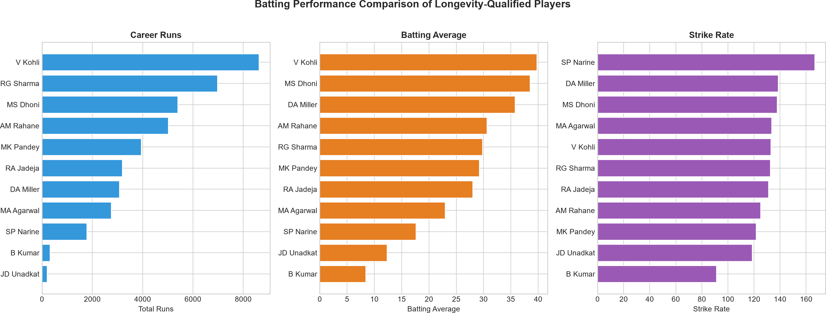
Fig. 4. Batting performance comparison of longevity-qualified players from the 2012–2025 Study 2 dataset: career runs, batting average, and strike rate.

In Fig. 4, the colors distinguish the three metrics rather than indicating higher or lower player quality: blue represents career runs, orange represents batting average, and purple represents strike rate. The same color is used for all players within a metric panel so that color itself is not interpreted as a ranking or class label.
- Bowling Comparison: B. Kumar records 198 wickets and S. P. Narine records 192 wickets in the study population.
Narine records an economy rate of 1.31, while Kumar records 1.37.
V. Kohli has a bowling average of 27.75 and is represented by a relatively small bowling workload compared with the specialist bowlers in the study pool.
- Cross-Metric Patterns and Role Specialization: The z-score matrix in Fig. 6 illustrates differences between batting and bowling profiles.
V. Kohli has strongly positive values on several batting met-rics and negative values on bowling metrics, while specialist bowlers show the opposite pattern.
The radar comparison in Fig. 7 further illustrates that players with similar overall composite positions can have substantially different metric profiles.
- Class Definition: In the batting classification, a Class represents the player’s relative position within the longevity-

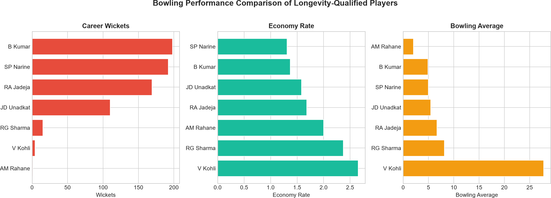

Fig. 5. Bowling performance comparison of longevity-qualified players from the 2012–2025 Study 2 dataset: career wickets, economy rate, and bowling average.

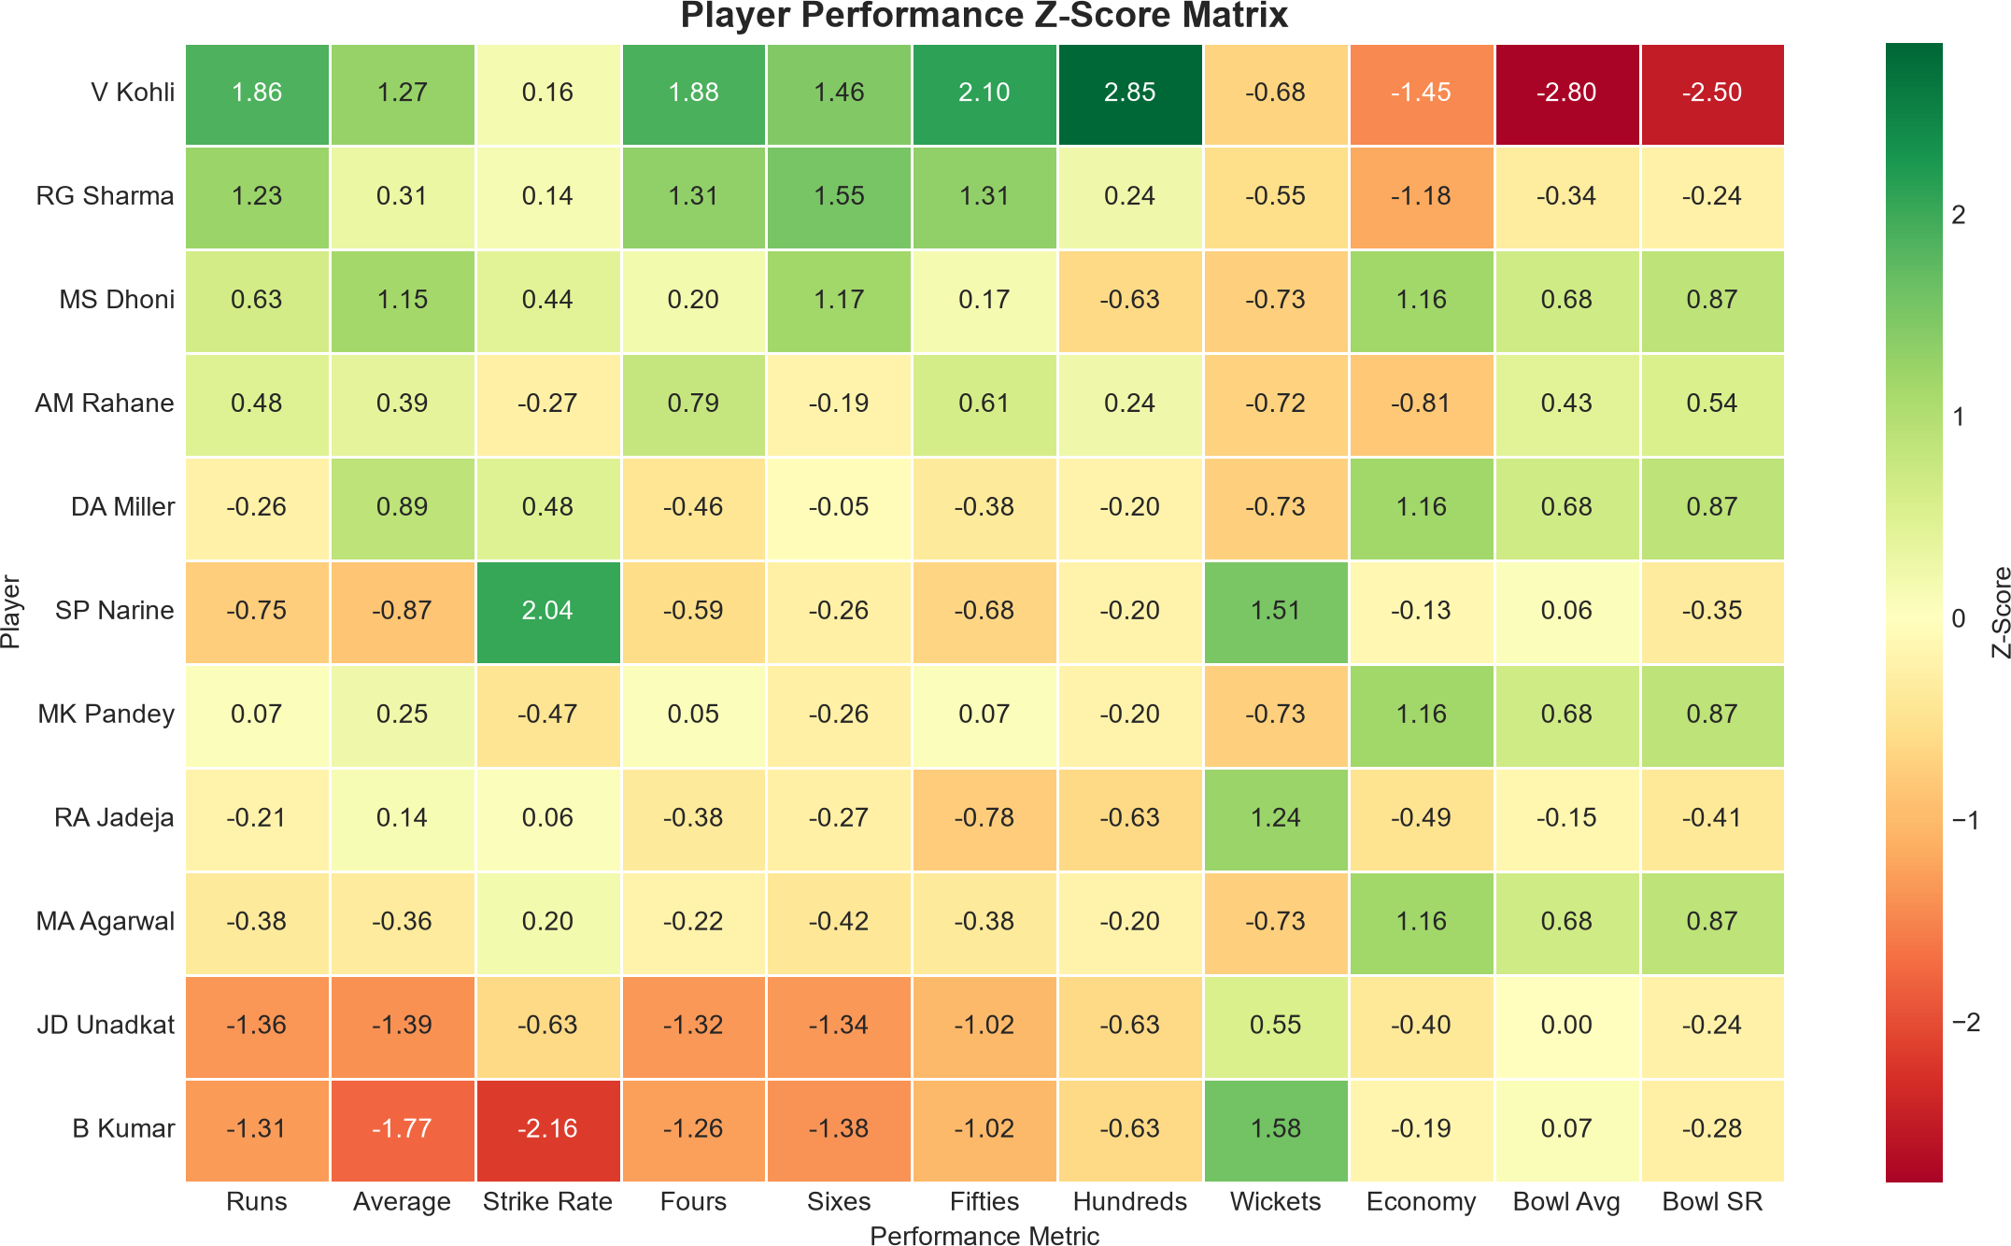

Fig. 6. Player performance z-score matrix for the 2012–2025 longevity-qualified population.

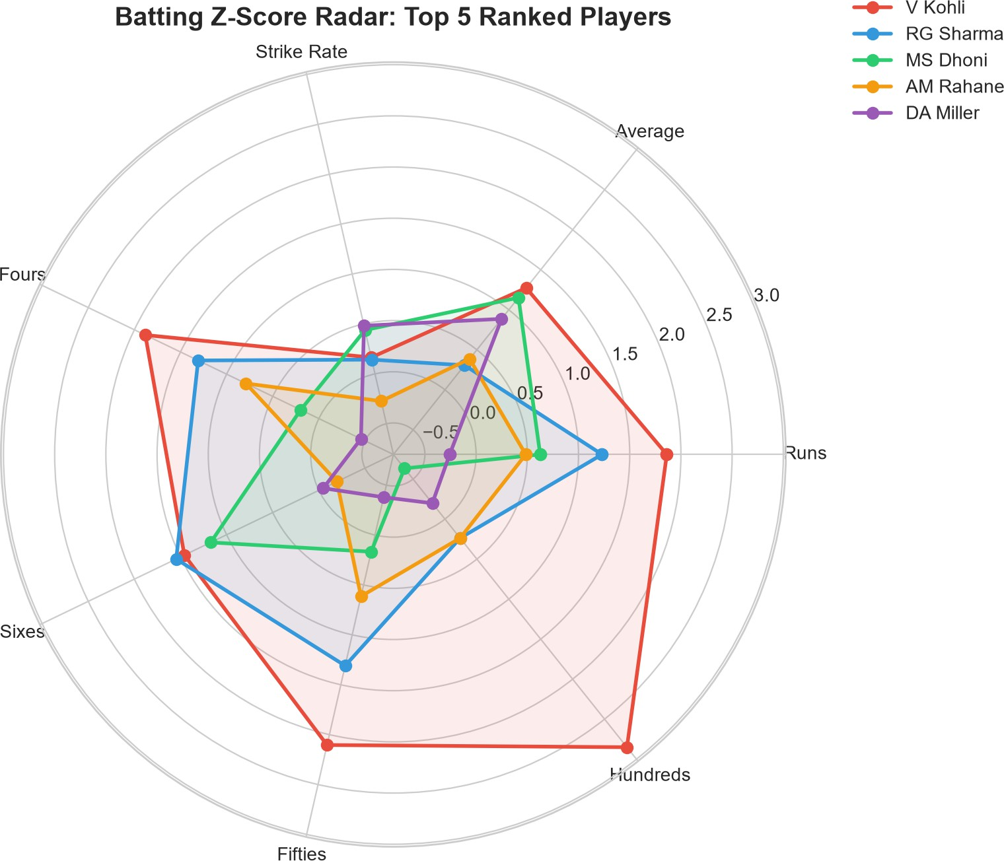

Fig. 7. Batting z-score radar for the top five players in the 2012–2025 longevity-qualified population.
qualified population based on batting average quintiles. It is a population-relative tier, not an absolute quality grade. Class 5 contains the highest quintile of batting-average values, Class
1 contains the lowest quintile, and Classes 2–4 represent the intervening quintiles. The same interpretation is applied to bowling, where four quartile-based classes are used for wickets-per-match (WPM). Thus, a class can change if the analyzed population or season range changes.

TABLE III
Batting Rank and Quintile Classification

Player | Average | Strike Rate | Innings | 100s | 50s | Class
V Kohli | 39.56 | 132.89 | 259 | 8 | 63 | Class 5 (Top 20%)
MS Dhoni | 38.30 | 137.45 | 241 | 0 | 24 | Class 5 (Top 20%)
DA Miller | 35.78 | 138.60 | 133 | 1 | 13 | Class 4 (60–80%)
AM Rahane | 30.50 | 125.02 | 183 | 2 | 33 | Class 4 (60–80%)
RG Sharma | 29.73 | 132.10 | 266 | 2 | 47 | Class 3 (40–60%)
MK Pandey | 29.20 | 121.52 | 161 | 1 | 22 | Class 3 (40–60%)
RA Jadeja | 27.86 | 130.30 | 194 | 0 | 5 | Class 2 (20–40%)
MA Agarwal | 22.97 | 133.53 | 125 | 1 | 13 | Class 2 (20–40%)
SP Narine | 17.62 | 166.51 | 118 | 1 | 7 | Class 1 (Bottom 20%)
JD Unadkat | 12.31 | 118.67 | 27 | 0 | 0 | Class 1 (Bottom 20%)

- Workload versus Output: Career innings and career runs provide a view of cumulative workload and output. Figure 8 illustrates this relationship while using batting average and strike rate as additional dimensions.
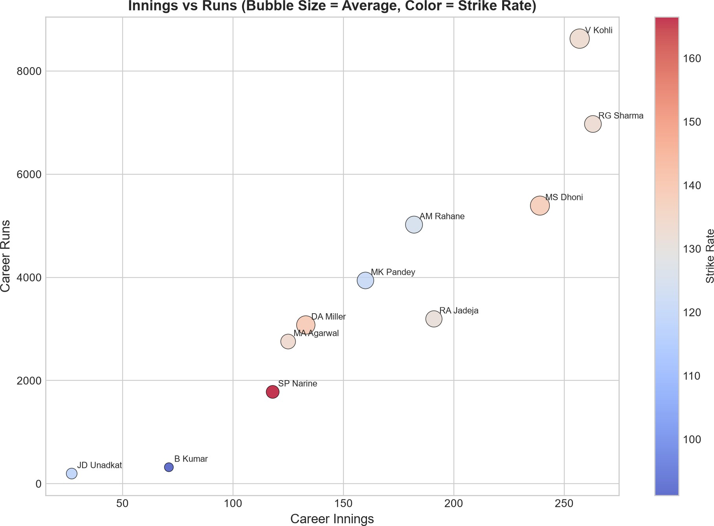

Fig. 8. Career innings versus career runs for the 2012–2025 longevity-qualified population, with batting average and strike rate as additional di-mensions.

The visualization uses bubble size to represent batting aver-age, while bubble color represents strike rate. Larger bubbles therefore indicate higher batting averages, whereas the color scale provides additional information about the player’s strike-rate performance. This allows the three batting dimensions to be interpreted together.
The batting-weighted composite score placed B. Kumar and
J. D. Unadkat at relatively low overall positions despite their bowling contributions.
This demonstrates why the composite score is treated as supplementary rather than as the primary player-classification method.

TABLE IV
Bowling Rank and Quartile Classification

Player | Innings | Wickets | WPM | Economy | Bowl Avg | Class
B Kumar | 190 | 198 | 1.04 | 1.37 | 4.85 | Class 4 (Top 25%)
SP Narine | 187 | 192 | 1.03 | 1.31 | 4.96 | Class 4 (Top 25%)
JD Unadkat | 111 | 110 | 0.99 | 1.58 | 5.43 | Class 3 (50–75%)
RA Jadeja | 225 | 170 | 0.76 | 1.68 | 6.68 | Class 2 (25–50%)
RG Sharma | 32 | 15 | 0.47 | 2.39 | 9.00 | Class 1 (Bottom 25%)
V Kohli | 26 | 4 | 0.15 | 2.65 | 27.75 | Class 1 (Bottom 25%)

C. Pairwise Head-to-Head Comparison
The quantile-based tier system positions each player relative to the population. However, players within the same tier can still exhibit substantial differences in individual performance metrics.
A pairwise comparison layer was therefore developed to quantify direct player-to-player differences.
For every pair of players within a role group, an n × n
comparison matrix is constructed for each relevant metric.
Let x_{i} denote the value of a performance metric for player
i.
For a higher-is-better metric, such as batting average or batting strike rate,
D_{ij} = x_{i} − x_{j}. (15)
D
Four matrices were generated for batting average, batting strike rate, bowling average, and economy rate.
The matrices were visualized using diverging red-to-green heatmaps centered at zero. Green represents an advantage for the row player and red represents an advantage for the column player.
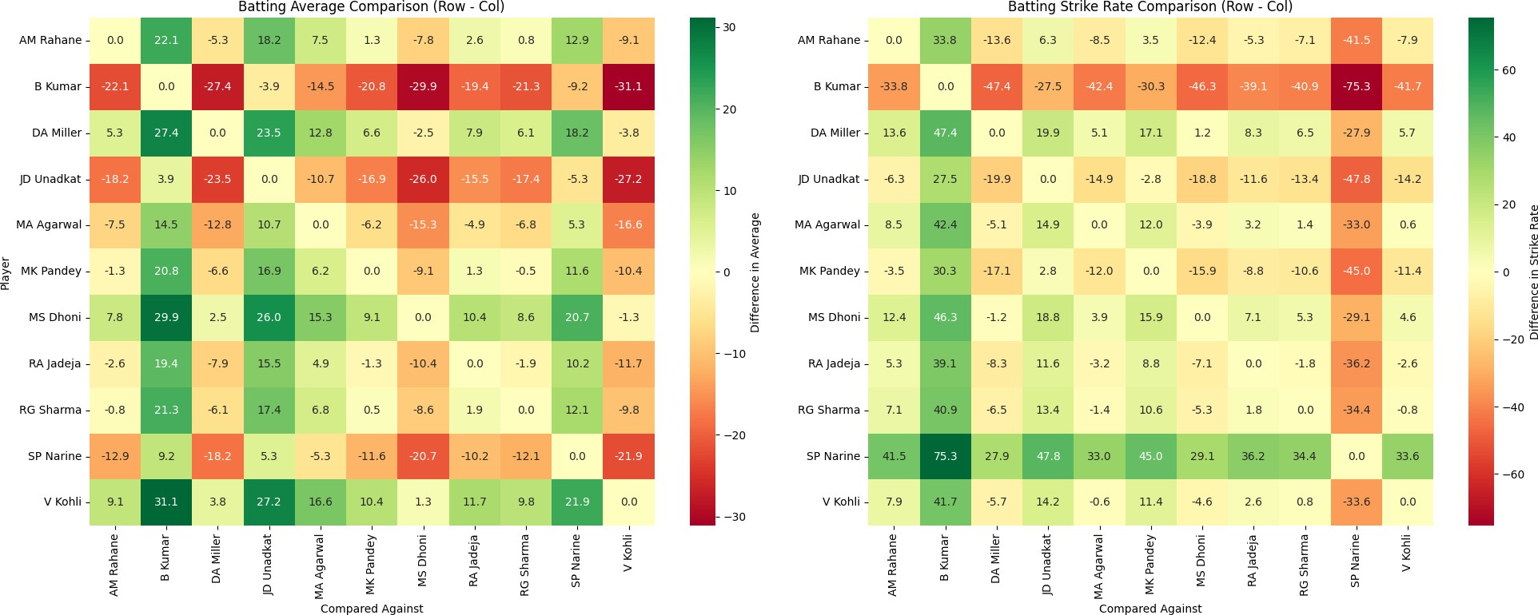

Fig. 9. Pairwise head-to-head comparison of longevity-qualified batters. Left: pairwise difference in batting average. Right: pairwise difference in batting strike rate. Green cells indicate an advantage for the row player, while red cells indicate an advantage for the column player. Diagonal elements are zero by construction.

Figure 9 presents the pairwise batting comparisons.
For V. Kohli and M. S. Dhoni, the batting averages are 39.56 and 38.30:

Therefore,
Avg Kohli,Dhoni
= 39.56 − 38.30 = 1.26. (22)

D_{ij} > 0 ⇒ x_{i} > x_{j}, D_{ij} < 0 ⇒ x_{i} < x_{j}. (16)
The strike rates are 132.89 and 137.45:

A positive value indicates an advantage for the row player,
SR
Kohli,Dhoni
D
= 132.89 − 137.45 = −4.56. (23)

while a negative value indicates an advantage for the column player.
For lower-is-better bowling metrics such as bowling average and economy rate, the formulation is reversed:
Thus, the two metrics provide different numerical directions for this pair.
For V. Kohli and D. A. Miller,

D_{ij} = x_{j} − x_{i}. (17) This transformation preserves a common interpretation: a
Avg
Kohli,Miller
D
For strike rate,
= 39.56 − 35.78 = 3.78. (24)

positive value represents an advantage for the row player.
SR
Kohli,Miller
D
= 132.89 − 138.60 = −5.71. (25)

The absolute numerical gap is

G_{ij} = |D_{ij}|. (18)
The pairwise matrices are antisymmetric:
Therefore, the pairwise values differ according to the metric being examined.
The largest observed strike-rate difference in the batting pool occurs between S. P. Narine and J. D. Unadkat:

D_{ij} = −D_{ji}. (19)
SR
Narine,Unadkat
D
= 166.51 − 118.67 = 47.84. (26)

The diagonal elements are zero:

D_{ii} = x_{i} − x_{i} = 0. (20)
Therefore,
D_{ii} = 0, D_{ij} + D_{ji} = 0. (21) These properties provide internal consistency checks for the
Narine has 118 batting innings in the study population, whereas Unadkat has 27 innings.
Consequently, this numerical comparison should be inter-preted in the context of different levels of batting exposure and player roles.
Figure 10 presents the corresponding bowling comparisons. For B. Kumar and S. P. Narine, the bowling averages are
4.85 and 4.96:

pairwise comparison calculations.
Avg
Kumar,Narine
D
= 4.96 − 4.85 = 0.11. (27)

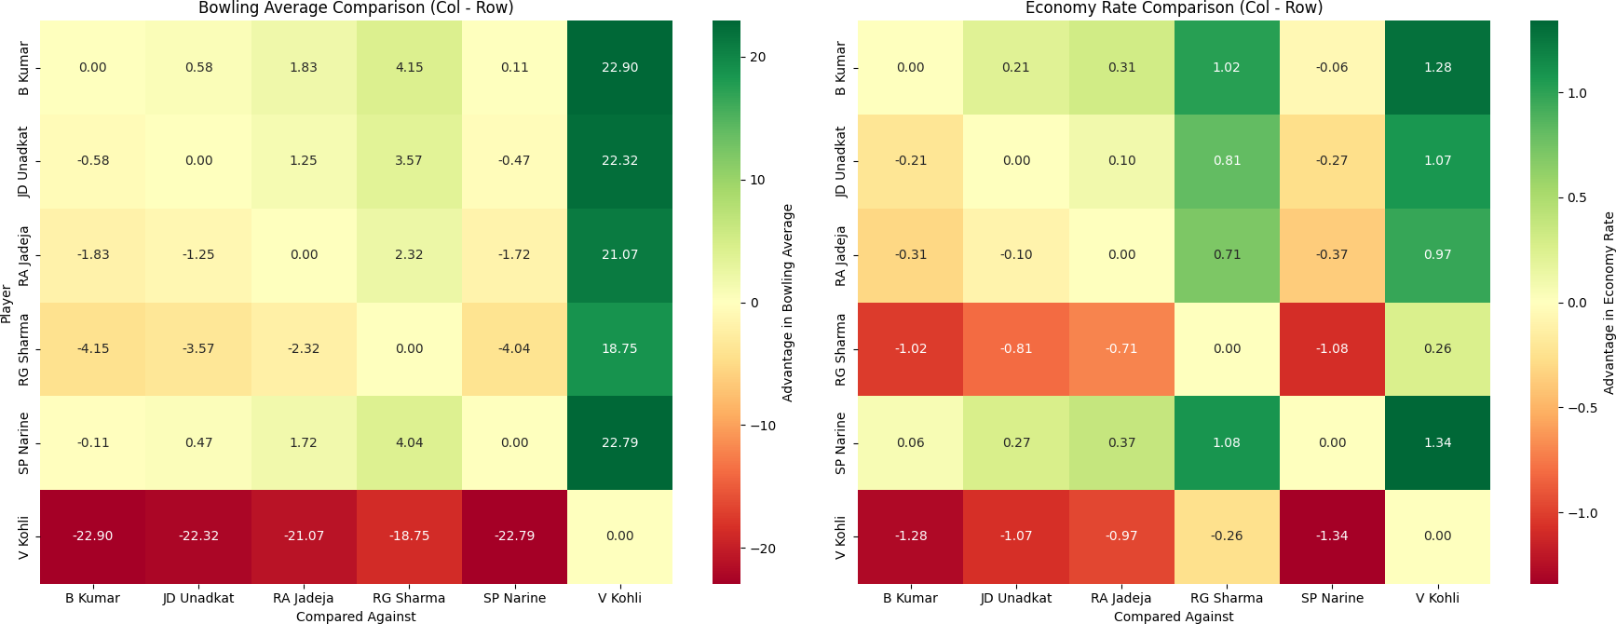

Fig. 10. Pairwise head-to-head comparison of longevity-qualified bowlers. Left: pairwise advantage based on bowling average. Right: pairwise advantage based on economy rate. Green indicates an advantage for the row player and red indicates an advantage for the column player.

Their economy rates are 1.37 and 1.31:
Overall, the pairwise comparison layer complements rather than replaces the quantile-based tier classification.
The tier system provides population-level classification, while the pairwise matrices provide direct numerical compar-isons between individual players.
- Discussion
- Why the R² Ceiling Is Data-Bound
Three observations support the interpretation that the test-performance ceiling is influenced by data limitations.
First, the train R² of 0.9888 under the unregularized model demonstrates that XGBoost has sufficient capacity to fit the training data.
Second, regularization reduced the train-test gap but did not recover test performance.

Econ Kumar,Narine
D
= 1.31 − 1.37 = −0.06. (28)
Third, the auction dataset does not contain several contex-tual variables that may affect auction price, including prior

The relatively small magnitudes indicate that these two
players have numerically close values on these particular metrics.
For B. Kumar and R. A. Jadeja, the bowling averages are
4.85 and 6.68:
auction price, retention decisions, franchise budget headroom, recent-form information, and injury status.
Therefore, the observed test performance should be inter-preted in the context of the available features rather than as a complete representation of auction valuation.

Avg Kumar,Jadeja
D
= 6.68 − 4.85 = 1.83. (29)
- Value and Limits of the Ranking Framework

For B. Kumar and V. Kohli,
The quantile-based ranking framework demonstrates how match-level aggregation, rate-based measures, and

Avg Kumar,Kohli
D
= 27.75 − 4.85 = 22.90. (30)
distribution-relative tiers can provide interpretable outputs from existing ball-by-ball data.

Their economy rates are 1.37 for Kumar and 2.65 for Kohli:
Unlike the batting-weighted composite score, the separate batting and bowling classifications preserve role-specific in-

Econ
D
Kumar,Kohli
= 2.65 − 1.37 = 1.28. (31)
formation.

These comparisons should be interpreted in the context of player roles and bowling exposure. B. Kumar is represented primarily as a specialist bowler, whereas V. Kohli has a substantially smaller bowling workload.
The pairwise analysis therefore adds information that is not directly available from the independently ranked tables. A ranking indicates relative population position, while a pairwise matrix quantifies the numerical separation between two players.
The distinction can be expressed as

Pairwise Information = Direction + Magnitude. (32)
The direction is determined by the sign of D_{ij}, while the magnitude is represented by |D_{ij}|.
Importantly, the pairwise differences are descriptive and
metric-specific. No statistical significance test or confidence interval is applied.
A small numerical gap therefore indicates only that the observed values are close for the selected metric. Similarly, a large numerical difference does not by itself establish an overall difference in player performance because player role, sample size, playing exposure, and metric selection must also be considered.
This reduces the influence of unrelated metrics when inter-preting specialist players.
- Practical Use
The Study 2 tiering framework can be used as a descrip-tive player-assessment tool for comparing players within the analyzed population.
It can support retention analysis, scouting, and identification of players with different performance profiles.
The Study 1 auction-price model has a time-based test R² of 0.5395 and an MAE of approximately INR 14.89 million. Because the model does not contain several contextual auction variables, its output is more appropriately interpreted as a valuation reference rather than an exact bidding amount.
- Limitations
The longevity criterion requires players to appear in every season from 2012 to 2025.
This produces a small population of 11 qualifying players. Therefore, the Study 2 results should not be interpreted as a ranking of all IPL players.
The tier boundaries are calculated from the analyzed popu-lation and may change if the season range or player selection criteria change.

The auction dataset covers 2008–2017 and therefore does not represent later auction conditions and rule changes.
The role of the Status variable in the auction dataset also cannot be fully resolved without additional documentation regarding how the variable was constructed and when the information became available relative to the auction outcome.
- Future Work
Future extensions include incorporating retention history and previous auction price as lagged features, applying SMOTE or cost-sensitive learning to address underrepresented high-value auction classes [7], evaluating LSTM, ARIMA, and ETS models for player-form trajectories [6], and investigating Transformer-based sequence models for longitudinal player-performance analysis [4], [5].
Another important extension is to combine player valuation with optimization-based squad selection under budget, role, and overseas-player constraints [8].
This would move the system from individual player valua-tion toward a broader auction decision-support framework.
- Conclusion
This paper investigated IPL auction analytics through two complementary studies: auction-price prediction using XG-Boost regression and player evaluation through a quantile-based ranking framework.
The results demonstrate that evaluation methodology has a substantial effect on reported model performance.
A random train-test split produced a test R² of 0.6580, whereas the time-based evaluation produced a test R² of 0.5395.
This difference highlights the importance of season-aware evaluation when historical data are used to model future auction outcomes.
The study also demonstrates that model methodology alone cannot compensate for missing contextual variables.
The auction dataset does not contain several factors that may influence auction prices, including retention history, franchise budget information, recent form, injury status, and previous auction prices.
Therefore, the auction-price model should be interpreted as a decision-support and valuation reference rather than a system for determining exact bidding amounts.
The second study developed a role-specific quantile-based ranking framework for batting and bowling.
Match-level aggregation, rate-based measures, and distribution-relative tiering produced interpretable classifications while avoiding the limitations of a single batting-weighted composite score.
The pairwise head-to-head layer further complements the tier classifications by providing direct numerical differences between players.
The combination of population-level tiers and pairwise metric comparisons provides both relative classification and transparent player-to-player analysis.
Overall, the work demonstrates that effective cricket ana-lytics requires both appropriate methodology and sufficiently informative data.
The proposed ranking framework provides a foundation for player assessment, while the auction-price analysis establishes a basis for future work involving richer contextual variables, constrained squad optimization, and interpretable decision-support systems.
References
- X. Schelling and S. Robertson, “A development framework for decision support systems in high-performance sport,” Int. J. Sports Sci. Coach., vol. 15, no. 4, pp. 456–468, 2020.
- K. Passi and N. Pandey, “Increased prediction accuracy in the game of cricket using machine learning,” Int. J. Comput. Appl., vol. 181, no. 17,
pp. 1–6, 2018.
- R. P. Bunker and F. Thabtah, “A machine learning framework for sport result prediction,” Int. J. Comput. Inf. Eng., vol. 11, no. 6, pp. 137–144, 2017.
- A. Vaswani et al., “Attention is all you need,” in Proc. Adv. Neural Inf. Process. Syst. (NIPS), Long Beach, CA, USA, 2017, pp. 5998–6008.
- J. Devlin, M.-W. Chang, K. Lee, and K. Toutanova, “BERT: Pre-training of deep bidirectional transformers for language understanding,” in Proc. NAACL-HLT, 2019, pp. 4171–4186.
- R. J. Hyndman and G. Athanasopoulos, Forecasting: Principles and Practice, 2nd ed. Melbourne, Australia: OTexts, 2018.
- H. He and E. A. Garcia, “Learning from imbalanced data,” IEEE Trans. Knowl. Data Eng., vol. 21, no. 9, pp. 1263–1284, Sep. 2009.
- L. Lamas et al., “Optimization models for team selection in high-performance sport,” 2015.
- F. Doshi-Velez and B. Kim, “Towards a rigorous science of interpretable machine learning,” in Proc. AAAI/ACM Conf. AI, Ethics, Soc. (AIES), 2017, pp. 1–7.
- N. Mehrabi et al., “A survey on bias and fairness in machine learning,” ACM Comput. Surv., vol. 54, no. 6, 2021.
- S. Amershi et al., “Software engineering for machine learning: A case study,” in Proc. ICSE-SEIP, 2019, pp. 291–300.
- T. Chen and C. Guestrin, “XGBoost: A scalable tree boosting system,” in Proc. 22nd ACM SIGKDD Int. Conf. Knowledge Discovery and Data Mining, 2016, pp. 785–794.

